**Educational Organisation Using Service Now**

**Team Id:** NM2025TMID14596

**Team Members:** 4

**Team Leader: SIVANESH KRISHNAN R**

**Team Member 1:** KISHORE D

**Team Member 2:** MUGESH SAI D

**Team Member 3:** DEEPAK E

**Problem Statement:** **​**

**​**Educational organizations face inefficient, siloed processes for managing requests, leading to slow response times and a lack of transparency.

**​Objective:**

Implement ServiceNow to create a centralized platform that streamlines services for students and staff. This will improve the user experience, boost efficiency through automation, and provide data for better decision-making.

**​Skills:**

**​**ServiceNow Administration, IT Service Management (ITSM), Business Analysis, Workflow Automation, UI Development, Integrations, Reporting and Analytics, and Project Management.

**Description:**

The Educational Management System is a comprehensive platform designed to streamline administrative tasks within educational institutions. It facilitates efficient management of student and teacher data, simplifies the admission process, and provides tools for monitoring student progress.

### Setting up ServiceNow Instance

1. Sign up for a developer account on the ServiceNow Developer site “https://developer.servicenow.com”.
2. Once logged in, navigate to the "Personal Developer Instance" section.
3. Click on "Request Instance" to create a new ServiceNow instance.
4. Fill out the required information and submit the request.
5. You'll receive an email with the instance details once it's ready.
6. Log in to your ServiceNow instance using the provided credentials.
7. Now you will navigate to the ServiceNow.

**Creating a Update Set**

1.Click on All >> Local update sets .

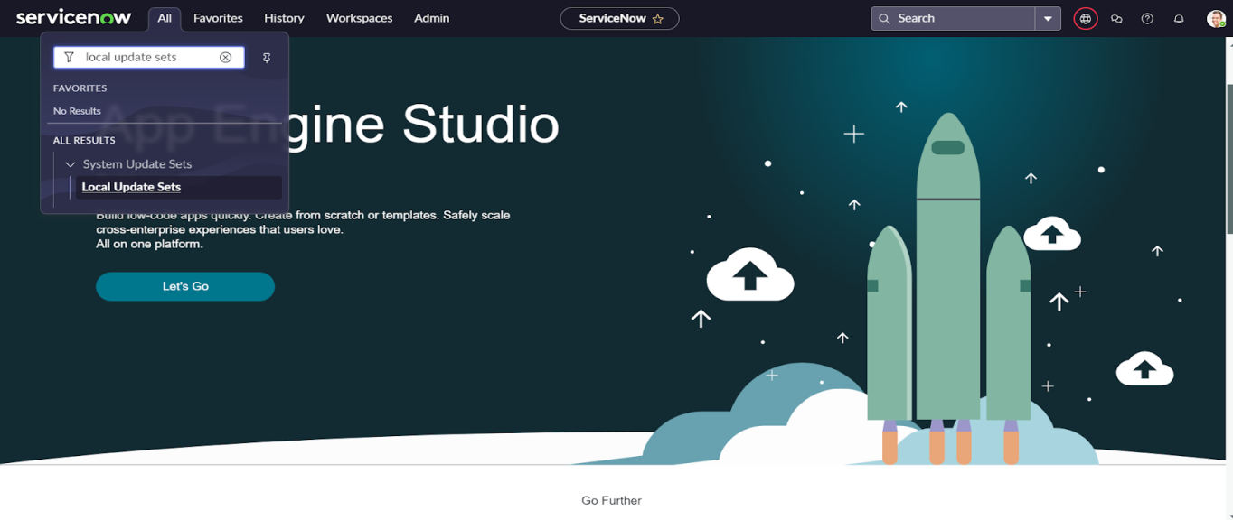

2.Click on new

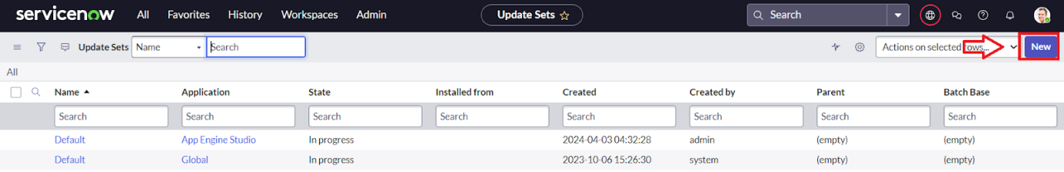

3.Enter the Details Name: Educational Organisation >> Click on Submit and make Current.

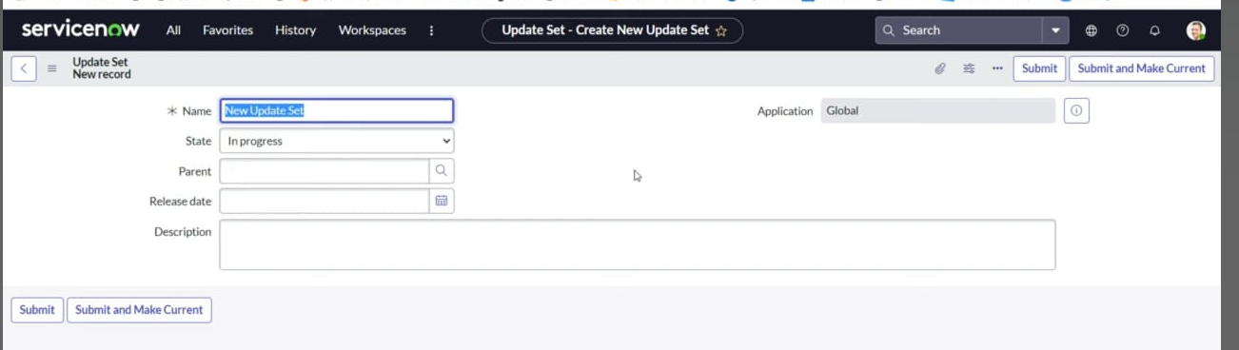

### Creating a Table

### Creating Salesforce Table

* All >> Tables.

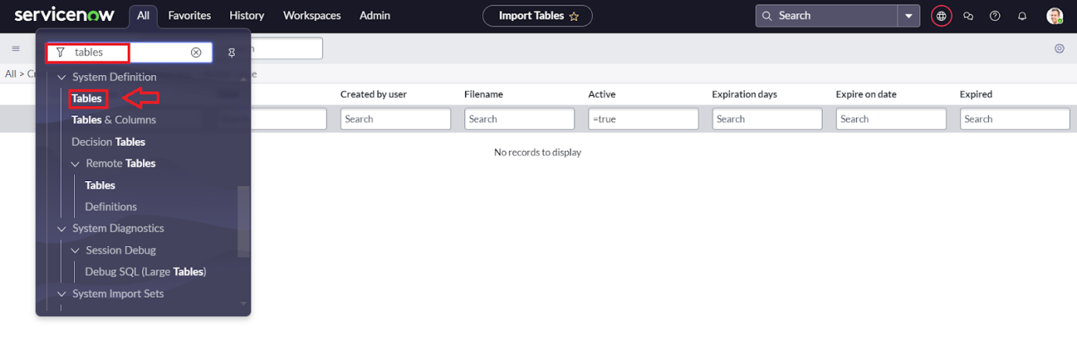

* Click on new

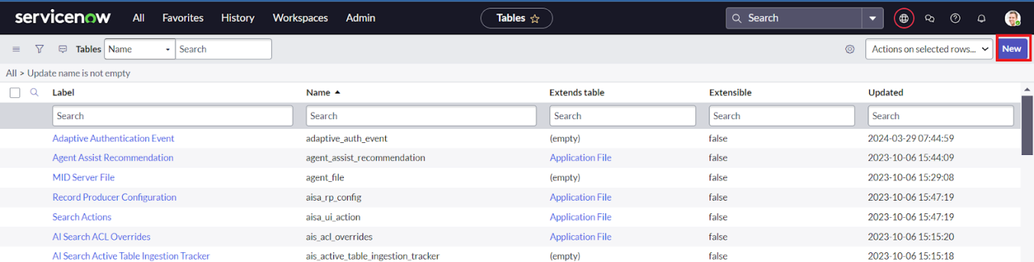

* Enter the Label(Anything you want): Salesforce >> Click on Name it will Automatically generate Api name.

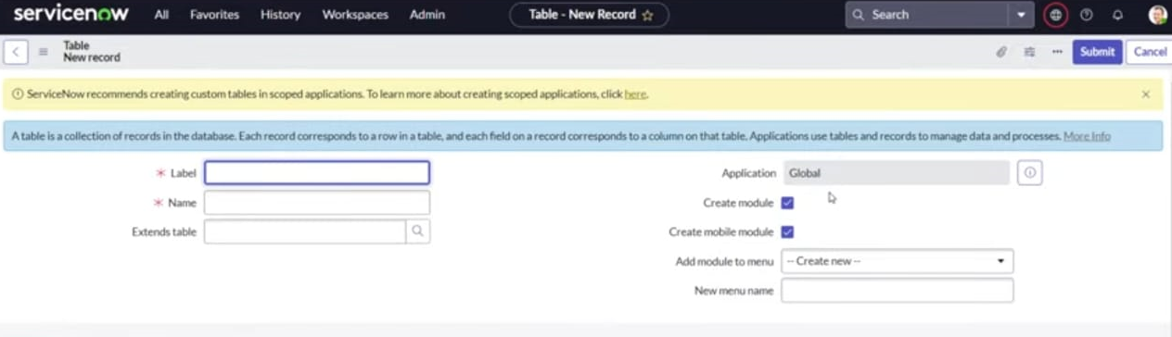

* Create columns as given below,Double Click on Column label and Enter the Column labels and click on the tick mark >> Give Type as given .

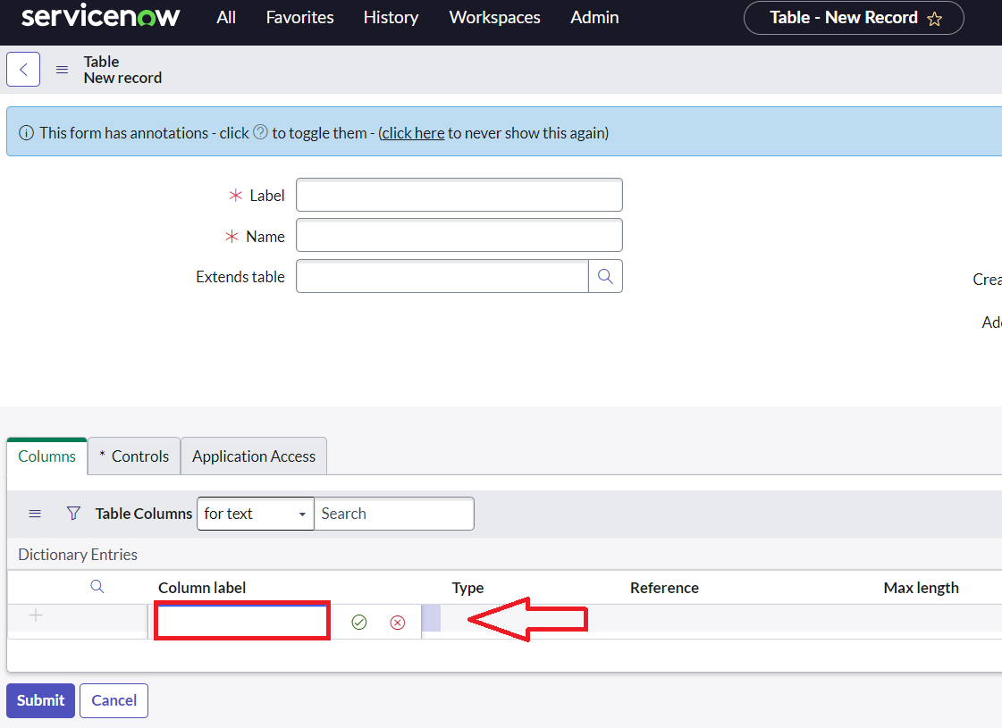

x

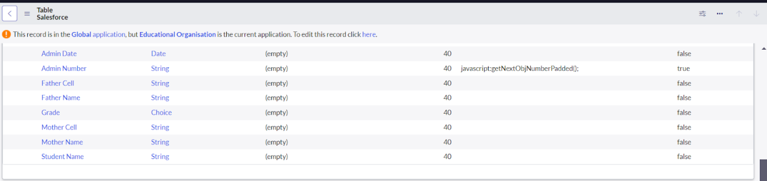

* For “Admin Number” Give Display as True and right click on the toggle bar on top >> save.

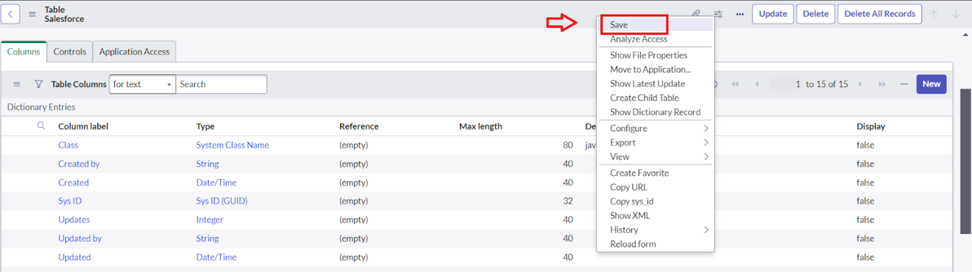

* Click on controls >> Enable Extensible.

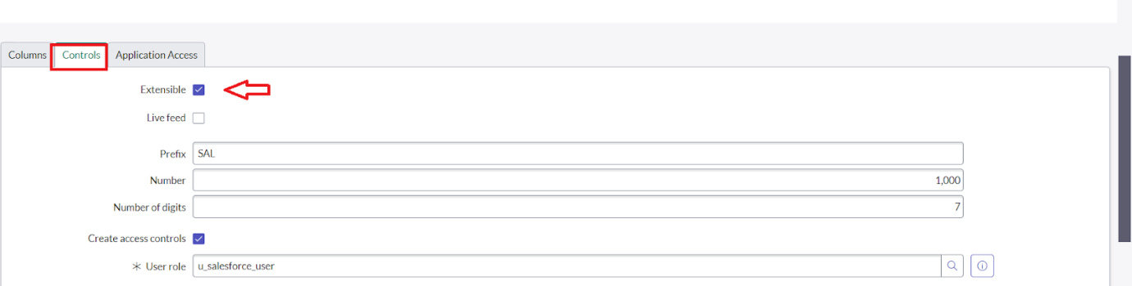

* Click on “Admin Number” column, In Related Links Click on Advanced View >> Default View (Enable Use dynamic default) >> select Get Next Padded Number in Dynamic default value >> Update .

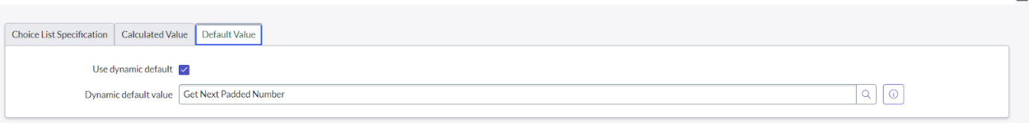

* Click on “Grade” Column >> Click on Choices and give Label,Value and Sequence as given below.

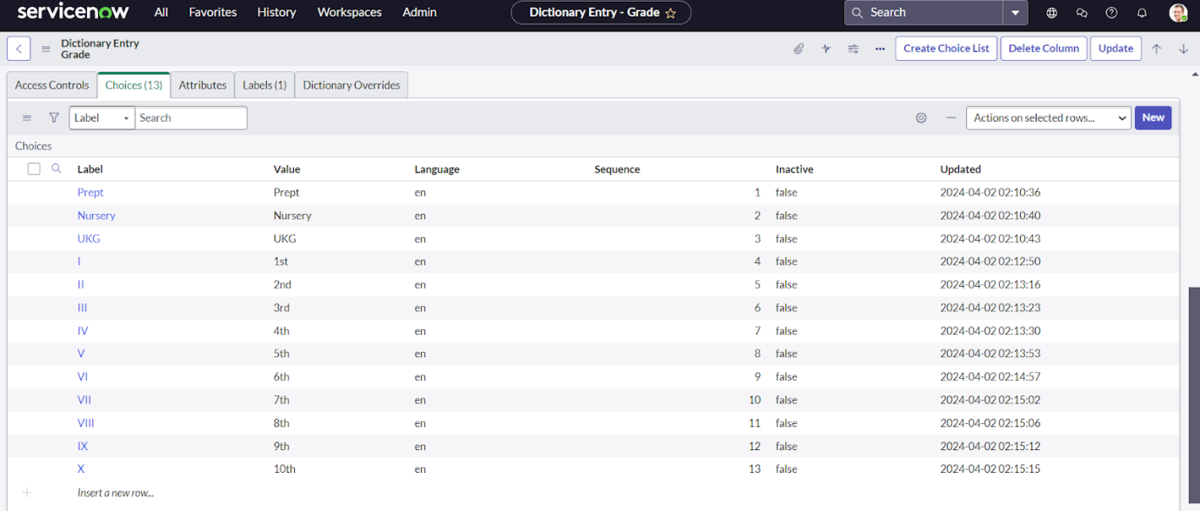

**Creating Admission Table**

* Create an Admission Table with Columns given.
* Select Extends Table >> Salesforce and also

Select Add module to menu >> Salesforce.

* Create Fields as shown

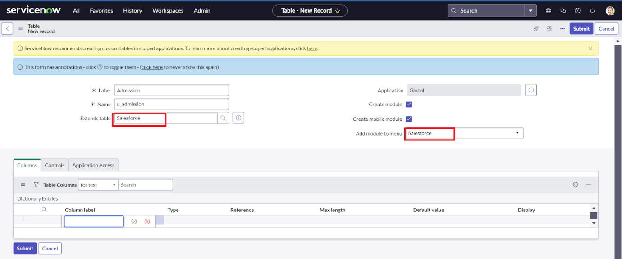

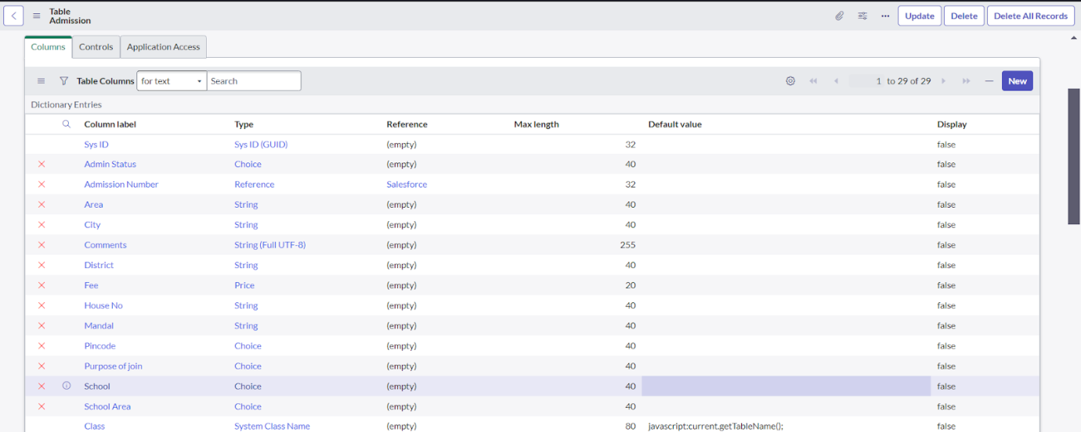

* Create choice for Admin Status as:

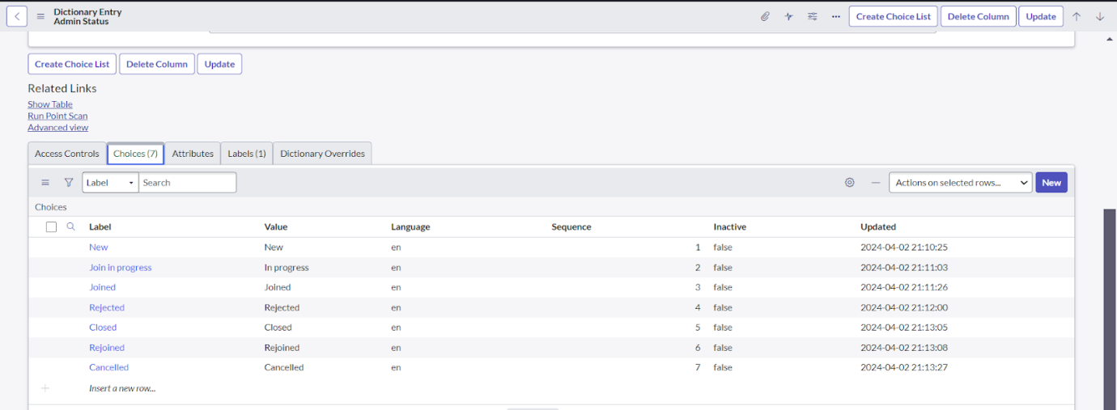

* Create choice for Pincode as:

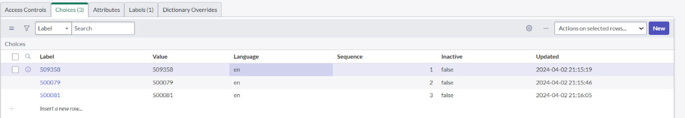

* Create choice for Purpose of Join as:

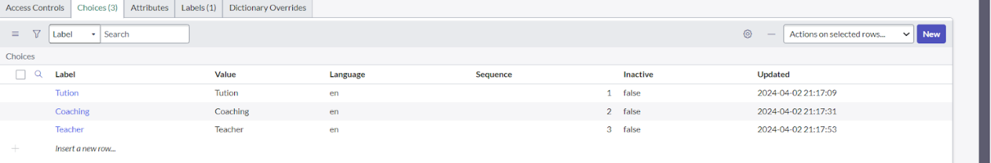

* Create choice for School as:

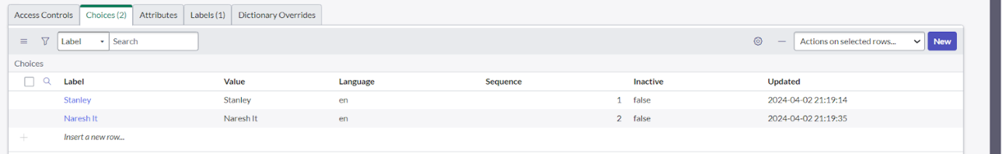

* Create choice for School Area as:

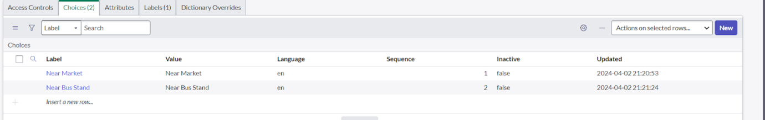

### Creating Student Progress Table

* Create a Student Progress Table with Columns given.
* Select Add module to menu >> Salesforce.
* Create Fields as shown:

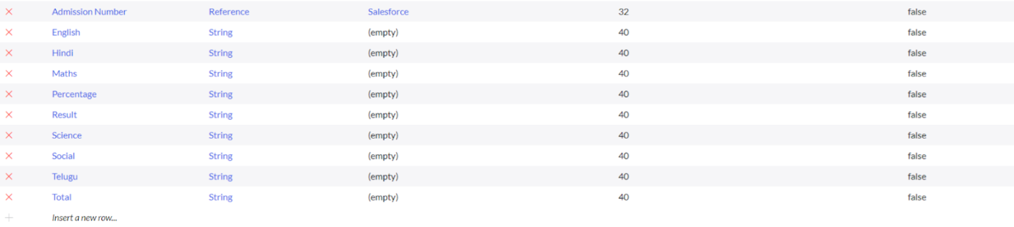

### Form Layout

**Configuring Table form for Student Progress Table**

* In the Student Progress Table Page , Click on Layout form.

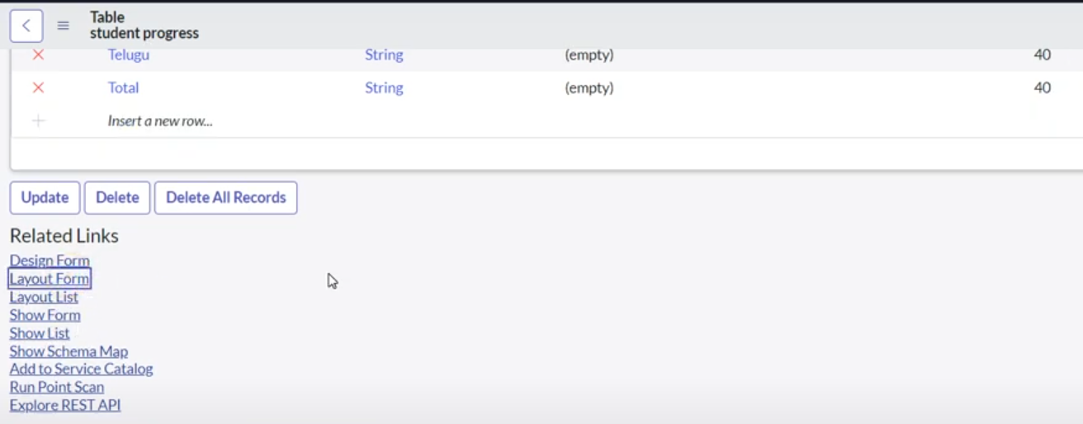

* Click on Admission Number [+] .

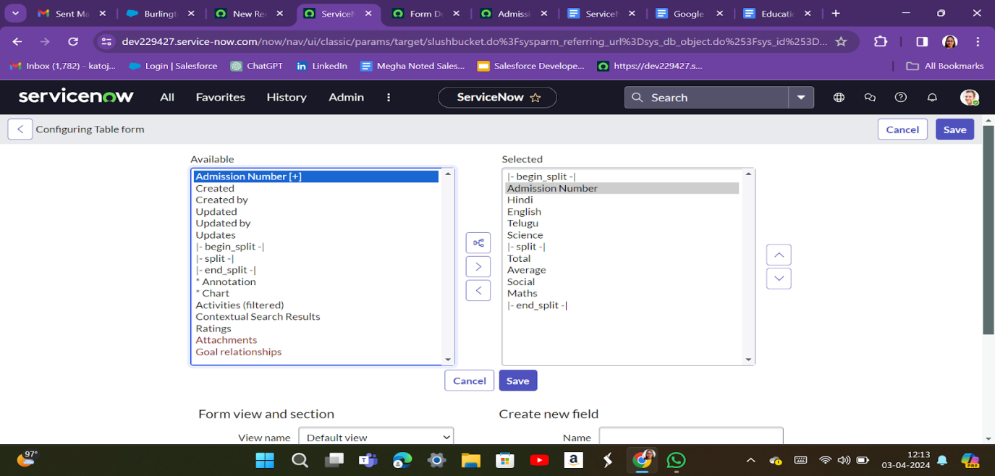

* Select below Admission Number fields in Available side and send it to selected side as below >> save.

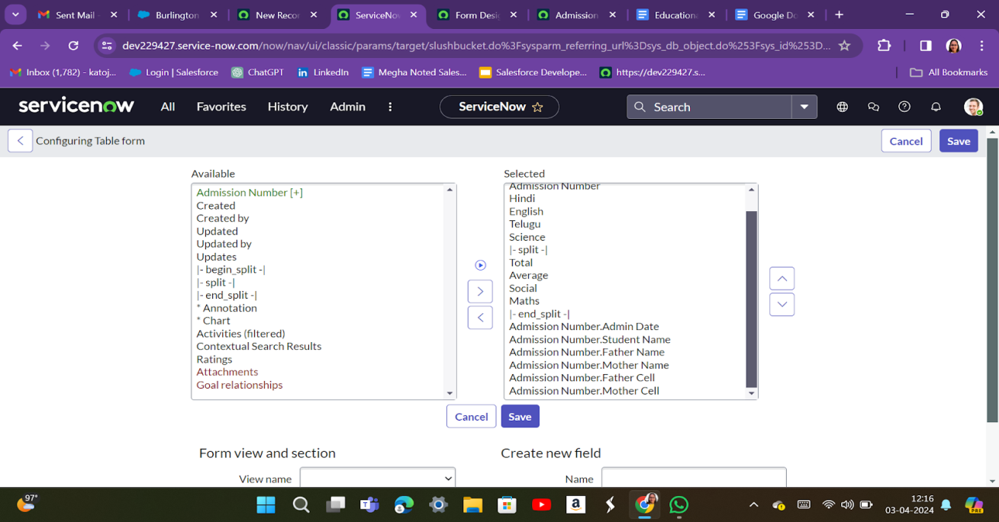

### Form Design

**Creating Form Design for Salesforce Table**

1. All >> System Definition >> Tables .
2. In Label Search for Salesforce and open .

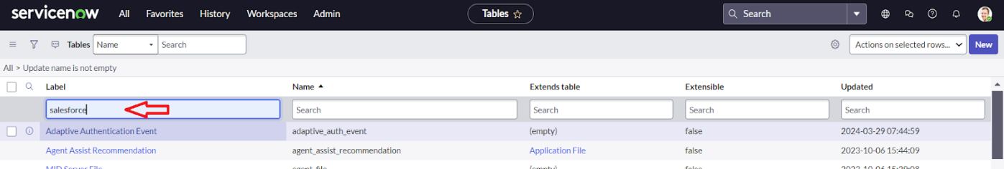

1. Right Click on top Toggle >> Configure >> Form Design.

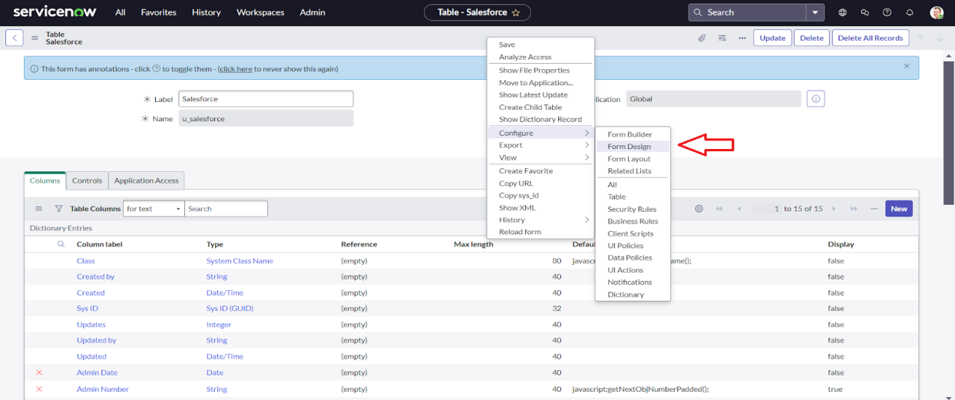

1. In drop down select Salesforce(u_salesforce).

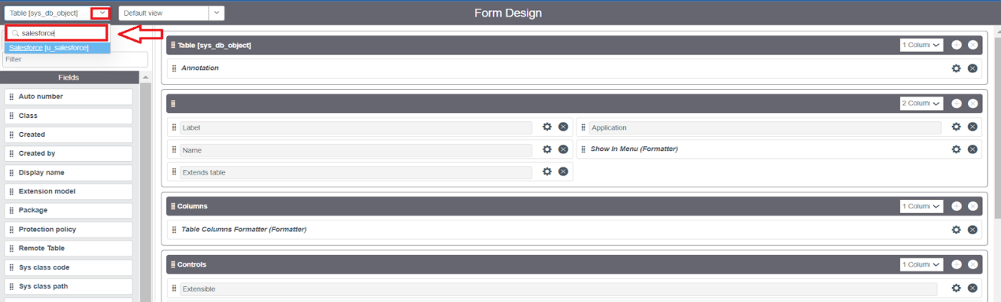

1. Drag and drop the fields to the left side as below.

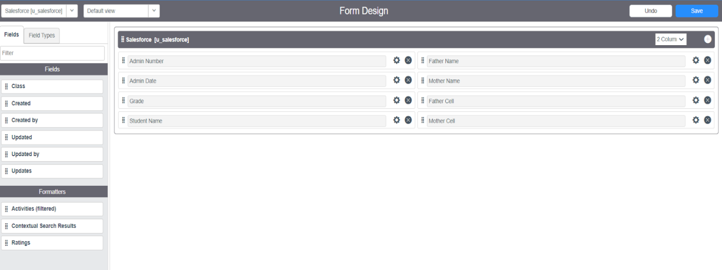

      6.Save.

### Creating Form Design for Admission Table

Follow the same steps as Activity1,Configure the fields as below and Save.

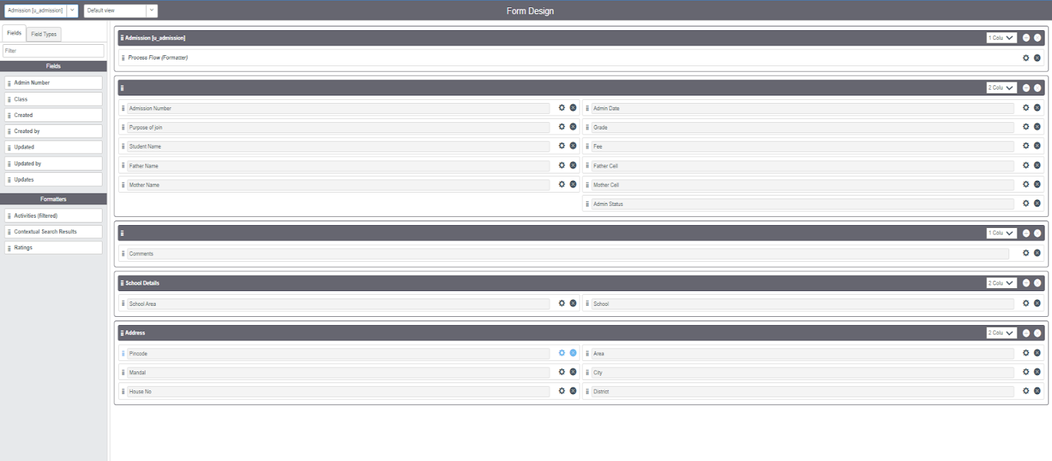

### Creating Form Design for Student progress Table

Follow the same steps as Activity1,Configure the fields as below and Save.

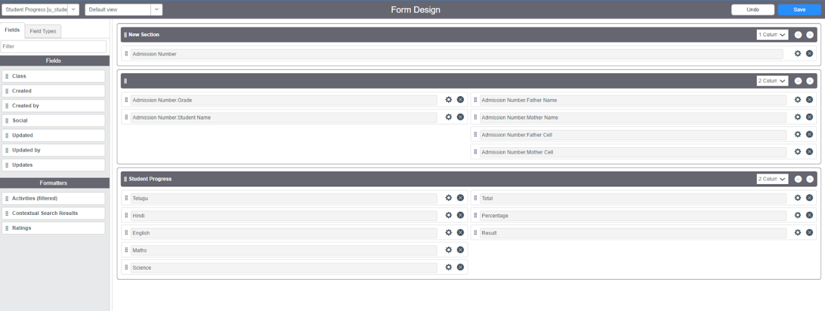

### Number Maintenance

### Creating Number Maintenance for Admin Number

* All >> Number Maintenance >> New

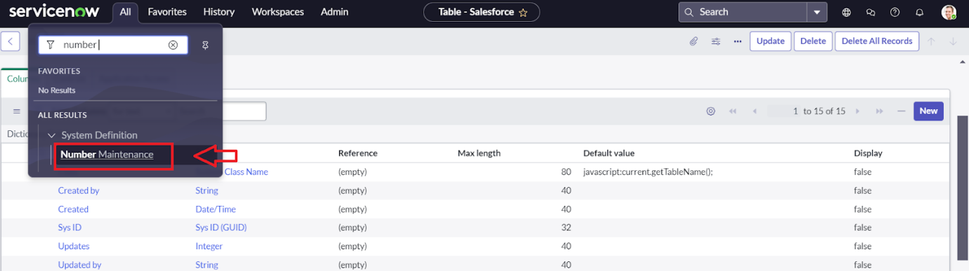

* Fill the details >> Submit.

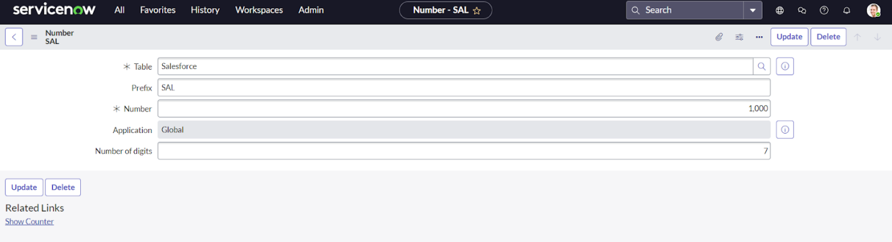

### Process Flow

### Creating Process Flow for Admission Table

* All >> Process Flow>> New.
* Fill the Details as given Below

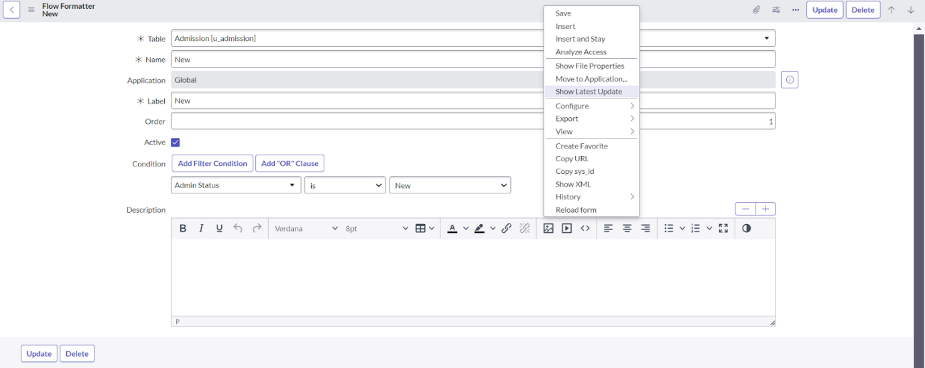

* Right Click on toggle and click on the save .
* Replace the Name and Label as below and click on Insert on stay.

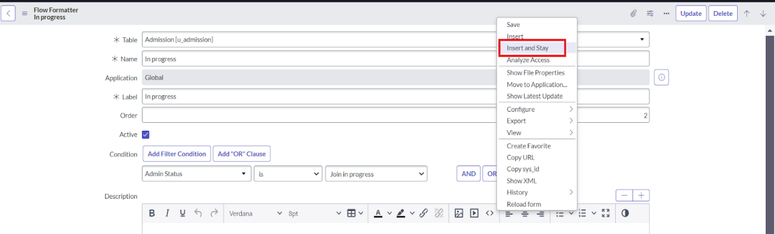

* Replace the Name and Label in order and click on Insert on stay.

Joined >> Rejected >> Rejoined >> Closed >> Cancelled.

* Order should be New >> InProgress >> Joined >> Rejected >> Rejoined >> Closed >> Cancelled.

**Client Script**

**Creating “Auto populate” Client Scripts for Admission Table**

* All >> Client Scripts >> New.
* Fill the Details as given.

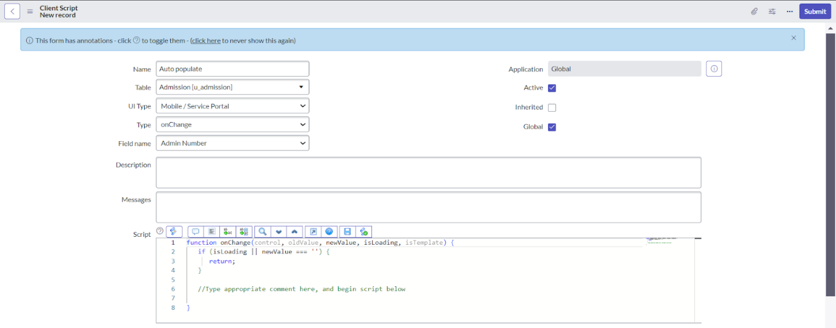

* Write the Code as below, Enable Isolate script and Save.

function onChange(control, oldValue, newValue, isLoading, isTemplate) {

   if (isLoading || newValue === '') {

      return;

   }

   //Type appropriate comment here, and begin script below

   var a = g_form.getReference('u_admission_number');

   g_form.setValue('u_admin_date',a.u_admin_date);

   g_form.setValue('u_grade',a.u_grade);

   g_form.setValue('u_student_name',a.u_student_name);

   g_form.setValue('u_father_name',a.u_father_name);

   g_form.setValue('u_mother_name',a.u_mother_name);

   g_form.setValue('u_father_cell',a.u_father_cell);

   g_form.setValue('u_mother_cell',a.u_mother_cell);

   g_form.setDisabled('u_admin_date',a.u_admin_date);

   g_form.setDisabled('u_grade',a.u_grade);

   g_form.setDisabled('u_student_name',a.u_student_name);

   g_form.setDisabled('u_father_name',a.u_father_name);

   g_form.setDisabled('u_mother_name',a.u_mother_name);

   g_form.setDisabled('u_father_cell',a.u_father_cell);

   g_form.setDisabled('u_mother_cell',a.u_mother_cell);

}

**Note**: Make sure the Field names should be the same as you created .

**Creating “Pincode Update” Client Scripts for Admission Table**

* Fill the Details as given.

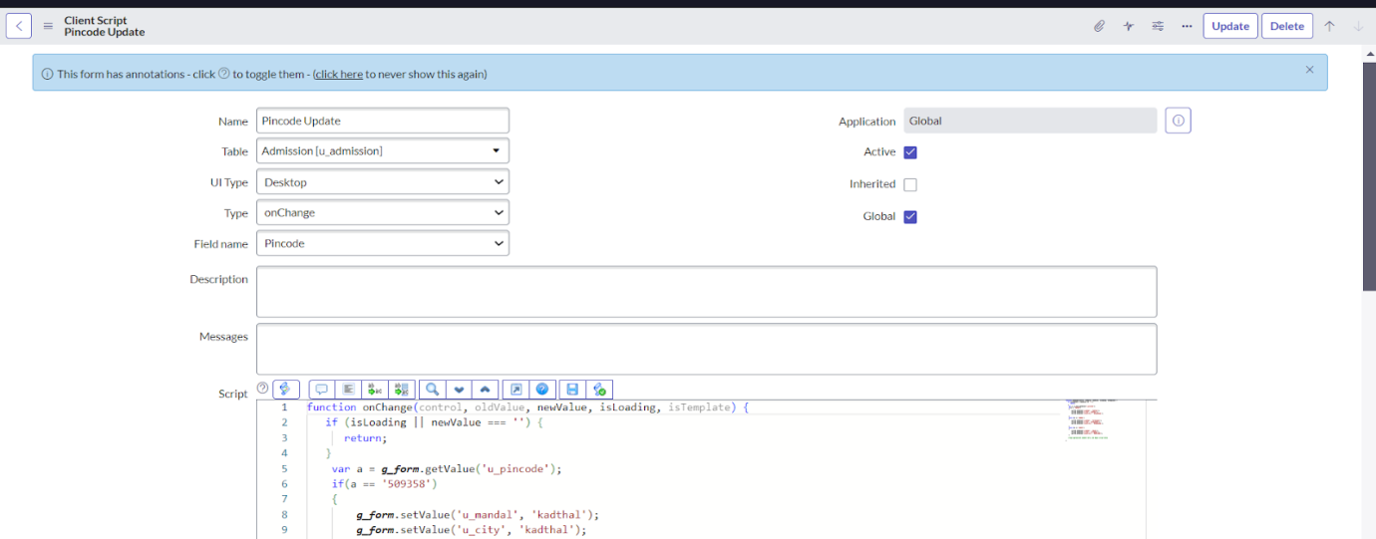

* Write the Code as below, Enable Isolate script and Save.

function onChange(control, oldValue, newValue, isLoading, isTemplate) {

   if (isLoading || newValue === '') {

      return;

   }

    var a = g_form.getValue('u_pincode');

if(a == '509358')

{

g_form.setValue('u_mandal', 'kadthal');

g_form.setValue('u_city', 'kadthal');

g_form.setValue('u_district', 'RangaReddy');

}

else if(a == '500081')

{

g_form.setValue('u_mandal', 'karmanghat');

g_form.setValue('u_city', 'karmanghat');

g_form.setValue('u_district', 'RangaReddy');

}

else if(a == '500079')

{

g_form.setValue('u_mandal', 'Abids');

g_form.setValue('u_city', 'AsifNagar');

g_form.setValue('u_district', 'Hyderabad');

}

   }

**Creating “Disable Fields” Client Scripts for Student progress Table**

* Fill the Details as given.

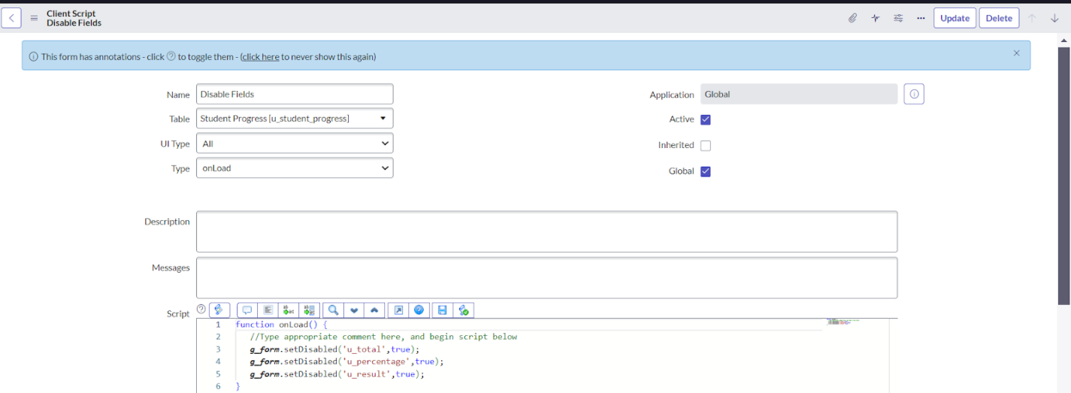

* Write the Code as below, Enable Isolate script and Save.

function onLoad() {

   //Type appropriate comment here, and begin script below

   g_form.setDisabled('u_total',true);

   g_form.setDisabled('u_percentage',true);

   g_form.setDisabled('u_result',true);

}

**Creating “Total Update” Client Scripts for Student progress Table**

* Fill the Details as given.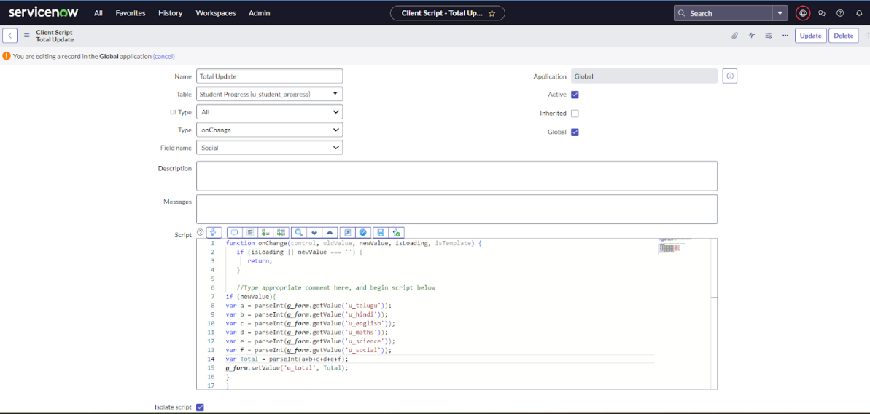

* Write the Code as below, Enable Isolate script and Save.

function onChange(control, oldValue, newValue, isLoading, isTemplate) {

   if (isLoading || newValue === '') {

      return;

   }

   //Type appropriate comment here, and begin script below

if (newValue){

var a = parseInt(g_form.getValue('u_telugu'));

var b = parseInt(g_form.getValue('u_hindi'));

var c = parseInt(g_form.getValue('u_english'));

var d = parseInt(g_form.getValue('u_maths'));

var e = parseInt(g_form.getValue('u_science'));

var f = parseInt(g_form.getValue('u_social'));

var Total = parseInt(a+b+c+d+e+f);

g_form.setValue('u_total', Total);

}

}

**Creating “Result” Client Scripts for Student progress Table**

* Fill the Details as given.

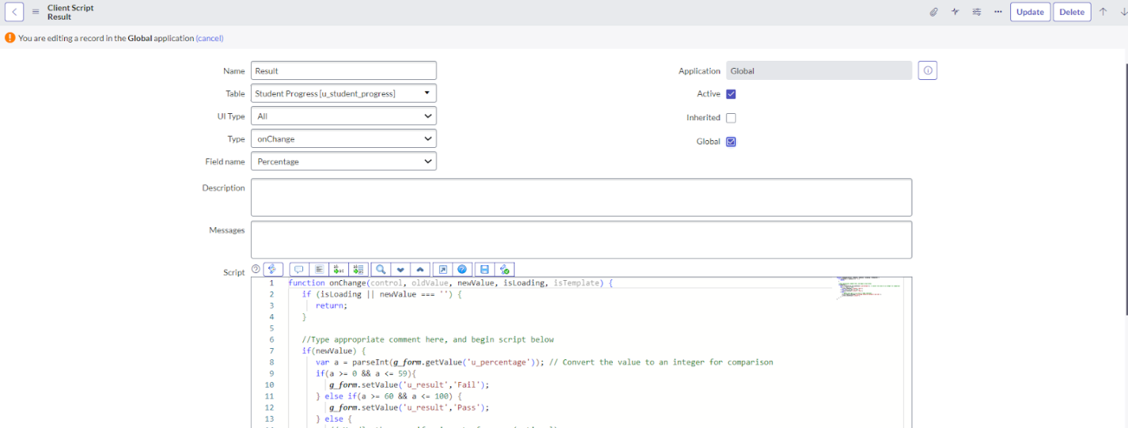

* Write the Code as below, Enable Isolate script and Save.

function onChange(control, oldValue, newValue, isLoading, isTemplate) {

   if (isLoading || newValue === '') {

      return;

   }

   //Type appropriate comment here, and begin script below

   if(newValue) {

      var a = parseInt(g_form.getValue('u_percentage')); // Convert the value to an integer for comparison

      if(a >= 0 && a <= 59){

         g_form.setValue('u_result','Fail');

      } else if(a >= 60 && a <= 100) {

         g_form.setValue('u_result','Pass');

      } else {

         // Handle the case if a is out of range (optional)

         g_form.addErrorMessage('Percentage should be between 0 and 100.');

         g_form.clearValue('u_result');

      }

   }

}

**Creating “Percentage” Client Scripts for Student progress Table**

* Fill the Details as given.

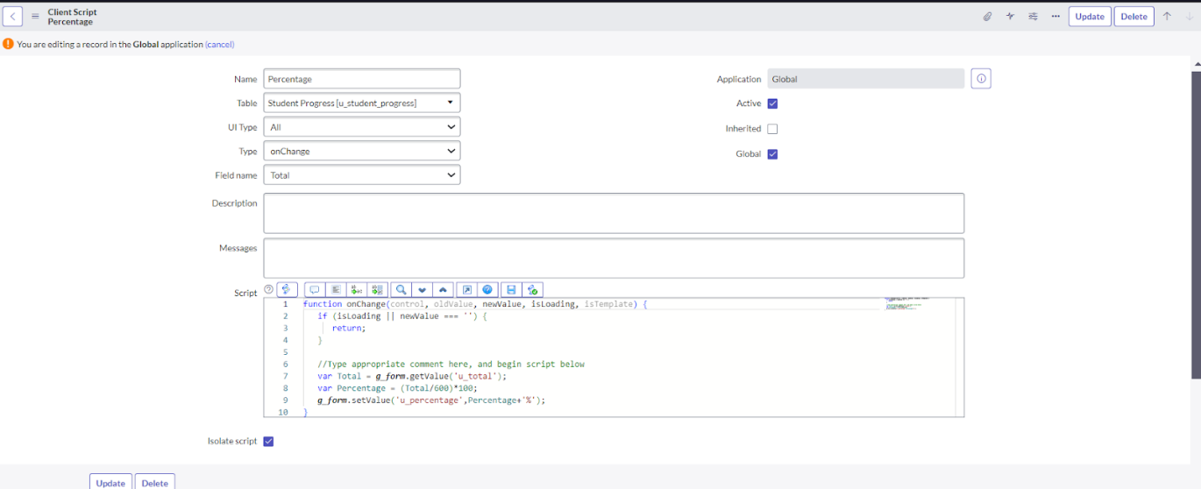

Write the Code as below, Enable Isolate script and Save.

function onChange(control, oldValue, newValue, isLoading, isTemplate) {

   if (isLoading || newValue === '') {

      return;

   }

   //Type appropriate comment here, and begin script below

   var Total = g_form.getValue('u_total');

   var Percentage = (Total/600)*100;

   g_form.setValue('u_percentage',Percentage+'%');

Result

